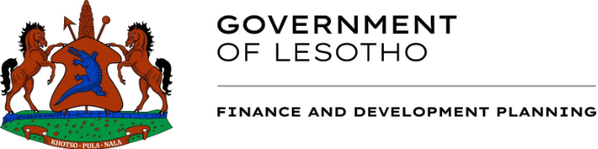
PRESS STATEMENT
THE PASSING AWAY OF MS HLOMPHO MATSOSO
The Ministry of Finance and Development Planning has learned of the untimely passing of our retired Deputy Accountant General Ms Hlompho Matsoso and her daughter Liteboho Matsoso.
Ms Matsoso served the Government of Lesotho and our Ministry in particular, with commitment, professionalism and integrity for many years. Her dedication and invaluable service will be fondly remembered by all who had the privilege of working with her.
As the ministry we extend our heartfelt condolences to the Matsoso family, relatives, friends and Accounting Cadre fraternity.
ENDS 04/11/2026

